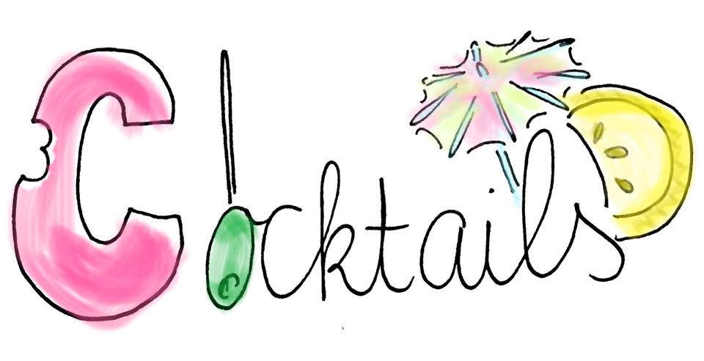

B52 € 4,00

Kahlua, baileys, grand marnier/cointreau

Mojito € 8,50

(non-alcoholic version available!) € 7,00

Mint, rum, limon, sparkling water

Cosmopolitan € 9,00

(non-alcoholic version available!) € 8,00

Vodka, cointreau, cranberry juice, lemon juice

Caipiriha € 9,00

Limon, sugar water, cachacha, crushed ice

Dutch espresso martini € 9,50

Vodka, kahlua, espresso, cream

Sours € 9,00

Amaretto/Jameson, lemonjuice, sugar water

Ask your bartender for your favorite cocktail!